Arctic Centre and Faculty of Art and Design, University of Lapland, Finland
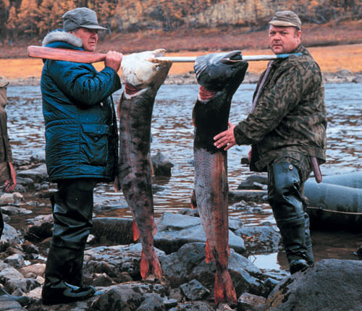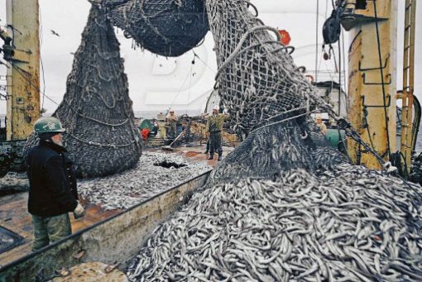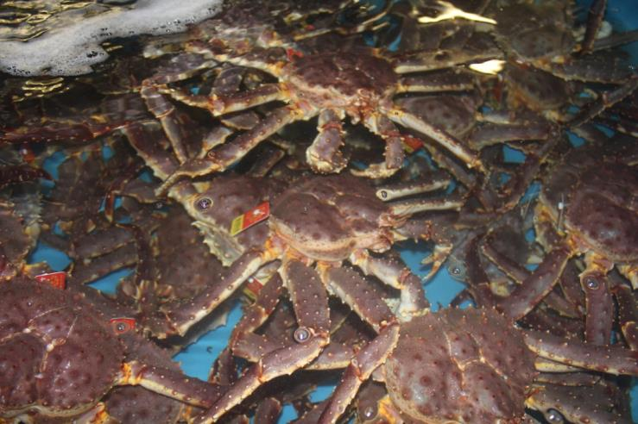
INVITATION
for the community meeting
‘Norwegian fjord: Living with Changes’ and Art Workshop ‘Stories of the Sea’ (ICE LAW project)
Programme:
June 7, Friday, Aurora House
14:00 – 18:30
Dr. Anna Stammler-Gossmann (Arctic Centre, University of Lapland). Local and Indigenous Perspectives. Introduction to the ICE LAW project
Climatic Changes and Local Perception: Experiences from the Fieldwork across the Arctic’. Presentation
Prof. Satu Miettinen (Faculty of Art and Design, University of Lapland). Art Workshop ‘Fish Mandala’
Dr. Anna Stammler-Gossmann. ‘Where the King Crab of Bugoynes comes from? Expedition to the Kamchatka, Russian Far East’. Photo and poster exhibition
Questions and discussion

June 8, Saturday, Aurora House
10:00 – 13:00
Anna Stammler-Gossmann. Fish – fishers – fisheries. Presentation
Satu Miettinen and Heidi Petarinen. Art Workshop ‘Water and Stories of the Sea: Designing Bugoynes Textile’.
EVERYBODY IS WARMLY WELCOME! Coffee and snacks will be served

