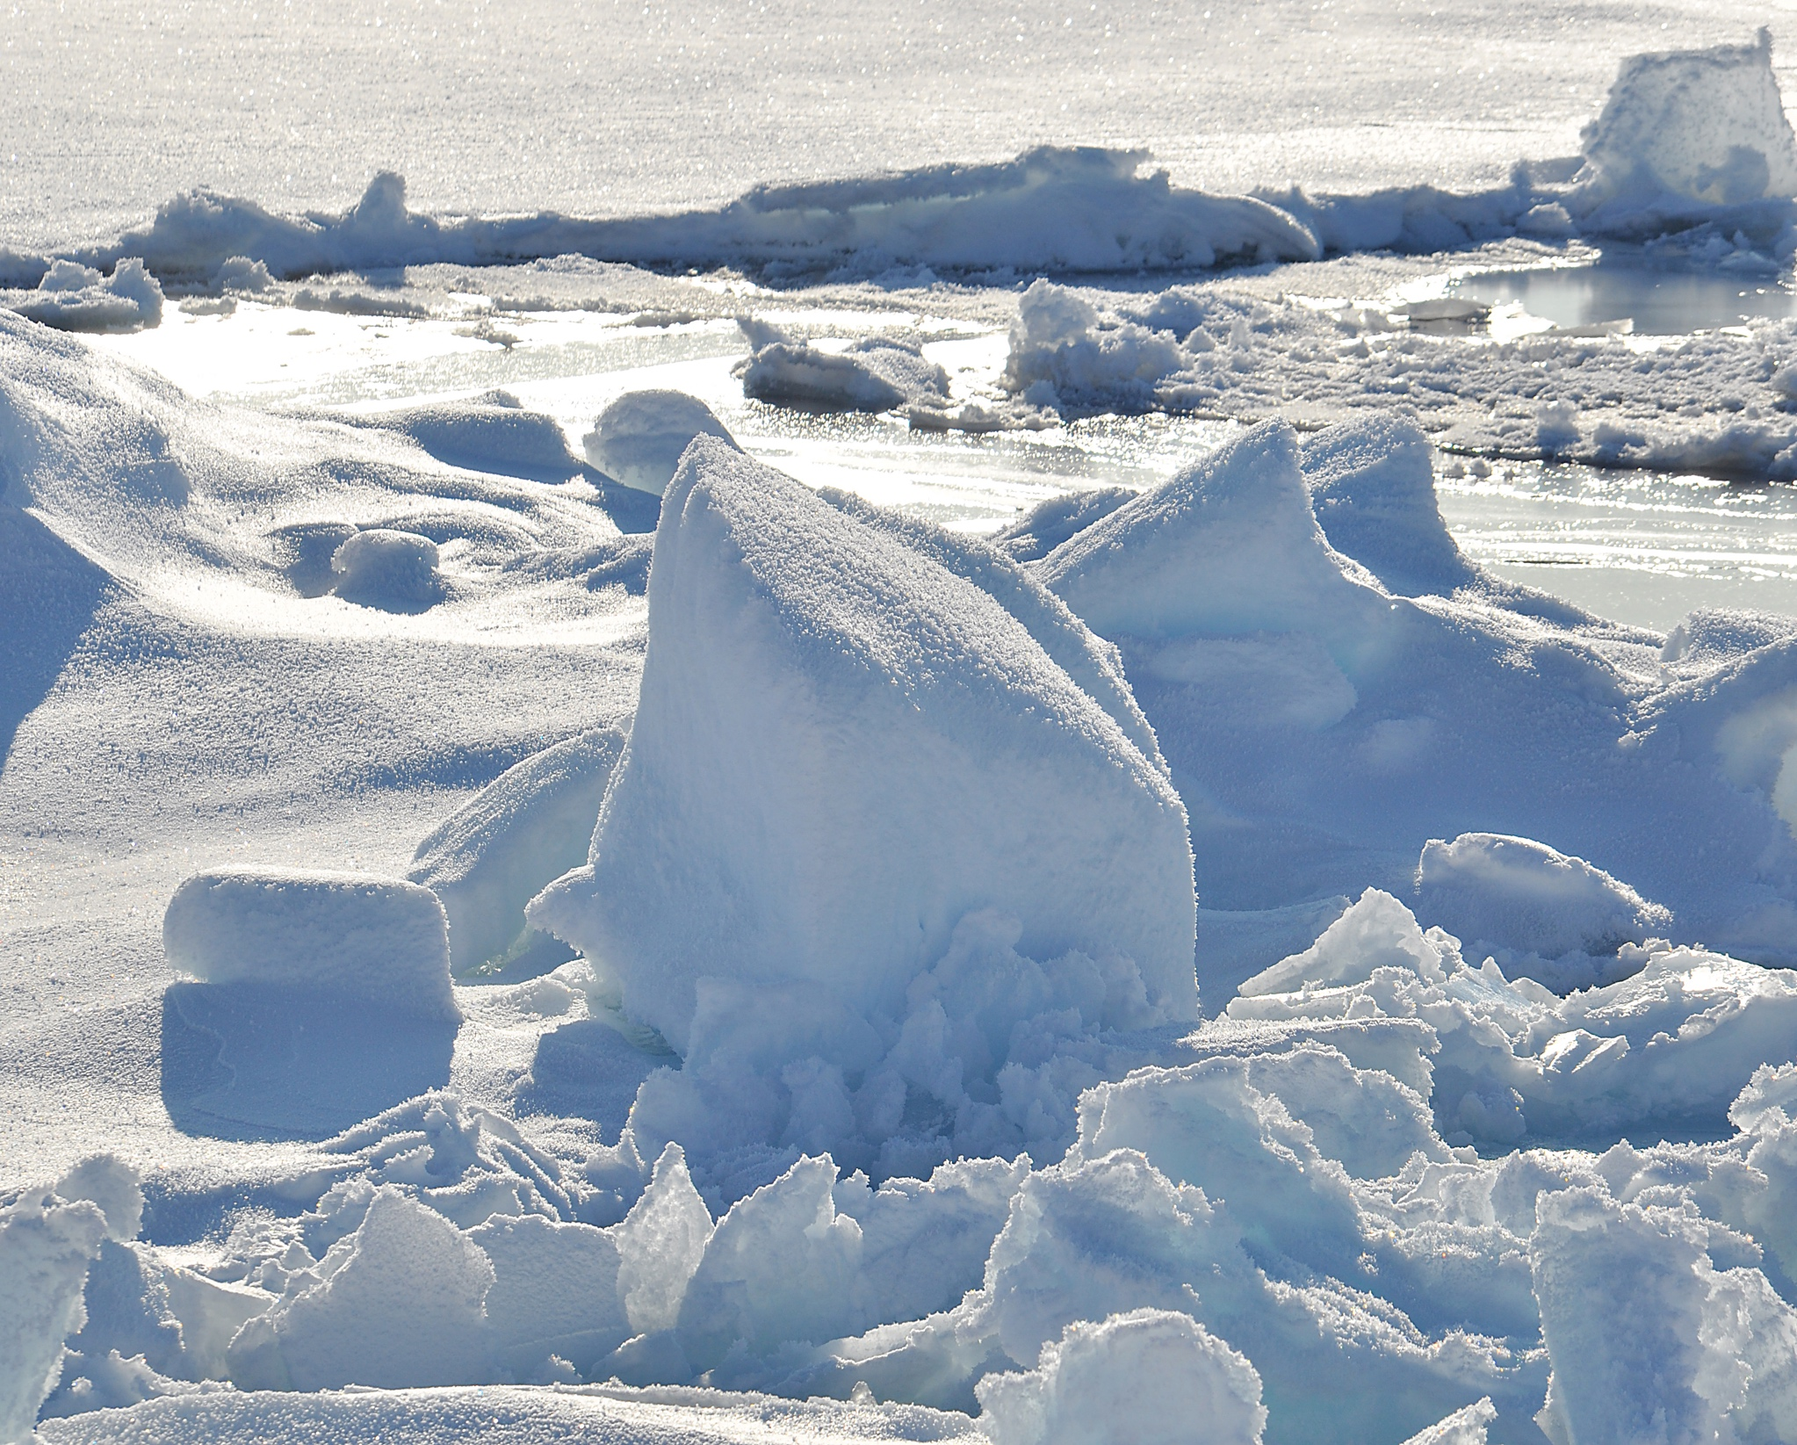

### PARTICIPANTS

Claudio Aporta. Marine Affairs Program. Dalhousie University. [claudio.aporta@dal.ca](mailto:claudio.aporta@dal.ca)

Johanne Bruun. Scott Polar Research Institute. University of Cambridge. [jmb283@cam.ac.uk](mailto:jmb283@cam.ac.uk)

Kate Coddington. Department of Geography and Planning. University at Albany, State University of New York. [kcoddington@albany.edu](mailto:kcoddington@albany.edu)

Elena Glasberg. Expository Writing Program. NYU. [eg922@nyu.edu](mailto:eg922@nyu.edu)

Stephanie Kane. Department of International Studies. Indiana University. [stkane@indiana.edu](mailto:stkane@indiana.edu)

Anne McNevin. Institute for Advanced Study // Department of Politics. The New School. [mcnevina@newschool.edu](mailto:mcnevina@newschool.edu)

Tom Narins. Department of Geography and Planning. University at Albany, State University of New York. [tnarins@albany.edu](mailto:tnarins@albany.edu)

Phil Steinberg. Department of Geography. Durham University. [philip.steinberg@durham.ac.uk](mailto:philip.steinberg@durham.ac.uk)

### WITH THANKS TO

### https://icelawproject.files.wordpress.com/2017/04/ice-law-colour.jpg

Leverhulme Trust [Ice Law Project International Network](https://icelawproject.org/)

University at Albany, SUNY

Questioning territory: extending concepts of territory through engagement with experience, affect, and embodiment

8 March 2019 University At Albany, State University Of New York Arts & Sciences 121

### AFTERNOON

12:45-1:45p Lunch

1:45-3:15p *Law. Science. Logic*.

Bodies of knowledge: notes on the corporeality of techno-scientific territories

Johanne Bruun

De and Re- Materializing Ice

Elena Glasberg

In Three Seas: Notes for a Multispecies Ice Law

Stephanie Kane

3:15-3:30p Break

3:30-4:15p Roundtables

4:45-4:30p Wrap up

6:30p Dinner. New World Bistro Bar.

### MORNING

9:00-9:30a Coffee, breakfast

9:30-10:00a Welcome, introductions

Andrei Lapenas, Chair, U Albany Department of Geography & Planning

Kate Coddington

10:00-10:30a *Context*

Inuit use and understanding of marine and territorial space

Claudio Aporta

10:30-11:30a *Borders. Sovereignty. Struggle*.

Statelessness: linking border struggles, anti-racist struggles (M4BL), and indigenous struggles

Anne McNevin

Missing from the Map: Chinese Exceptionalism, Sovereignty Regimes and the Belt Road Initiative

Tom Narins

11:30-11:45a Break

11:45-12:45p *Migration. Bodies. Terrain*.

From the lighthouse to the ICEhouse: Migrating surfaces and migrating bodies in an indeterminate seascape

Phil Steinberg

Territory as relation: Fertility, discipline, struggle

Kate Coddington